**What is Java?**

Java is a general purpose; object oriented programming language developed by Sun Microsystems of USA in 1995 later acquired by Oracle Corporation. Originally called Oak by James Gosling, one of the inventers of the language. Java was designed for the development of software for consumer electronic devices like TVs, VCRs, Toasters, set-top boxes and such other electronic machines. This goal had a strong impact on the development team which included James Gosling, Mike Sheridan, and Patrick Naughton discovered that the existing language like C and C++ had limitations in terms of both reliability and portability. However they modeled their new language Java on C and C++ but removed a numbers of features of C and C++ that were considered as source of problems and thus made Java a really simple, reliable, portable and powerful language.

Platform: Any hardware or software environment in which a program runs is known as a platform. Since Java has its own runtime environment (JRE) and API, it is called platform.

**Where it is used?**

There are many devices where Java is currently used. Some of them are as follows:

1. Desktop Applications such as acrobat reader, media player, antivirus etc.
2. Web Applications such as irctc.co.in, javatpoint.com etc.
3. Enterprise Applications such as banking applications.
4. Mobile
5. Embedded System
6. Smart Card
7. Robotics
8. Games etc.

**Types of Java Applications**

There are mainly 4 types of applications that can be created using Java programming:

1. **Standalone Application**

It is also known as **desktop application** or **window-based application**. **Standalone Application** an application that we need to install on every machine such as **media player**, **antivirus** etc.

**AWT (Abstract Window Toolkit)** and **Swing** technology are used in Java for creating standalone applications.

**Example**: Library Management System (LMS), Payroll System, Media player, antivirus, Paint etc.

1. **Web Application**

Web Applications are the client-server software application which is run by the client.

Currently, servlet, jsp, struts, jsf etc. technologies are used for creating web applications in Java.

**Example**: e-commerce website, Hotel Management System website, College website etc.

1. **Enterprise Application**

An application that is distributed in nature, such as banking applications Enterprise resource planning (ERP), customer relationship management systems (CRM), supplier relationship management systems (SRM) etc. It has the advantage of high level security, load balancing and clustering.

In Java, Enterprise Java Bean (EJB) is used for creating enterprise applications.

Example: Tally , SAP , HubSpot.

1. **Mobile Application**

An application that is created for mobile devices. Currently Android and Java ME (Micro edition) are used for creating mobile applications.

Example: WhatsApp, Xender etc.

**History of Java**

The history of Java starts from Green Team. Java team members (also known as Green Team), initiated a revolutionary task to develop a language for digital devices such as set-top boxes, televisions, VCRs, Toasters etc.

For the green team members, it was an advance concept at that time. But, it was suited for internet programming. Later, Java technology as incorporated by Netscape.

Currently, Java is used in internet programming, mobile devices, games, e-business solutions etc.

**There are given the major point that describes the history of Java.**

1) James Gosling, Mike Sheridan, and Patrick Naughton initiated the Java language project in June 1991 but Java was first released in 1995.The small team of sun engineers called Green Team.

2) Originally designed for small, embedded systems in electronic appliances like set-top boxes.

3) Firstly, it was called "Greentalk" by James Gosling and file extension was .gt.

4) After that, it was called Oak and was developed as a part of the Green project.

**Why Oak name for Java language?**

Oak is a symbol of strength and chosen as a national tree of many countries like U.S.A., France, Germany, Romania etc.

In 1995, Oak was renamed as "Java" because it was already a trademark by Oak Technologies.

**Why Java name for Java language?**

* The team gathered to choose a new name. The suggested words were "dynamic", "revolutionary", "Silk", "jolt", "DNA" etc. They wanted something that reflected the essence of the technology: revolutionary, dynamic, lively, cool, unique, and easy to spell and fun to say.
* According to James Gosling "Java was one of the top choices along with Silk". Since Java was so unique, most of the team members preferred Java.
* Java is an island of Indonesia where first coffee was produced (called Java coffee).
* Notice that Java is just a name not an acronym.
* Originally developed by James Gosling at Sun Microsystems (which is now a subsidiary of Oracle Corporation) and released in 1995.

**Java Version History**

|  |  |  |
| --- | --- | --- |
| **Java SE Version** | **Version Number** | **Release Date** |
| **JDK 1.0**  (Oak) | 1.0 | January 1996 |
| **JDK 1.1** | 1.1 | February 1997 |
| **J2SE 1.2** | 1.2 | December 1998 |
| **J2SE 1.3** | 1.3 | May 2000 |
| **J2SE 1.4** | 1.4 | February 2002 |
| **J2SE 5.0** | 1.5 | September 2004 |
| **Java SE 6** | 1.6 | December 2006 |
| **Java SE 7** | 1.7 | July 2011 |
| **Java SE 8** | 1.8 | March 2014 |
| **Java SE 9** | 9 | September, 21st 2017 |
| **Java SE 10** | 10 | March, 20th 2018 |
| **Java SE 11** | 11 | September, 25th 2018 |
| **Java SE 12** | 12 | March, 19th 2019 |
| **Java SE 13** | 13 | September, 17th 2019 |
| **Java SE 14** | 14 | March, 17th 2020 |
| **Java SE 15** | 15 | September, 15th 2020 |
| **Java SE 16** | 16 | March, 16th 2021 |
| **Java SE 17** | 17 | September, 14th 2021 |
| **Java SE 18** | 18 | March, 22nd 2022 |
| **Java SE 19** | 19 | September, 20th 2022 |
| **Java SE 20** | 20 | March, 21st 2023 |

1. JDK Alpha and Beta (1995)
2. JDK 1.0 (23rd Jan, 1996)
3. JDK 1.1 (19th Feb, 1997)
4. J2SE 1.2 (8th Dec, 1998)
5. J2SE 1.3 (8th May, 2000)
6. J2SE 1.4 (6th Feb, 2002)
7. J2SE 5.0 (30th Sep, 2004)
8. Java SE 6 (11th Dec, 2006)
9. Java SE 7 (28th July, 2011)
10. Java SE 8 (18th March, 2014)
11. Java SE 9 (2017)
12. Java SE 10 (2018)
13. Java SE 11 (2019)
14. Java SE 12 (2019)
15. Java SE 13 (2019)
16. Java SE 14 (2020)

**Features of Java Programming Language**

Java is Simple, Object oriented, Distributed, Robust, Platform independent, Secure, Architecture neutral, Portable, High performance, Multithreaded, Dynamic language.

1. **Simple**
2. Java is developed from C and C++ language.
3. Java is easy to learn and its syntax is quite simple, clean and easy to understand. The syntax is similar to C language.
4. The confusing and ambiguous concepts of C and C++ programming language are either left out in Java or they have been re-implemented in a cleaner way.

Eg : Pointers and Operator Overloading are not there in Java but were an important part of C++.

1. There is no structure, union keyword in Java
2. Java does not support multiple inheritance.
3. **Object Oriented Programming**

Java supports class, object, data encapsulation, data abstraction, inheritance, polymorphism that’s why Java is called OOP language.

1. **Distributed**

Java is also a distributed language. Programs can be designed to run on computer networks. Java has a special class library for communicating using TCP/IP protocols.

You can create such types of application in **Java that you can run on two or more than two machine**. Some part of that program is running on one machine and some part of program running on other machine.

Creating network connections is very much easy in Java as compared to C/C++.

Network programming (Socket Programming), Remote Method Invocation (RMI) and Enterprise Java Bean (EJB) are used for creating distributed application.

1. **Robust**

Robustness is the capacity of a computer system to handle the errors during execution and manage the incorrect input of data.

Java is robust because it utilizes strong memory management. There is an absence of pointers that avoids/bypasses security problem. There is automatic garbage collection in Java which runs on the Java Virtual Machine to eliminate objects which are not being accepted by a Java application anymore. There are type-checking mechanisms and exception-handling in Java. All these features make Java robust.

1. **Secured**

Java is best known for its security. With Java, we can develop virus free system. Java is secure because

* No explicit pointer
* Java programs runs inside a virtual machine.
* Java language provides security by default.
* Some security can also be provided by an application developer explicitly through SSL, Cryptography etc.

1. **Platform Independent**

Unlike other programming languages such as C, C++ etc which are compiled into platform specific machines. Java is guaranteed to be write-once, run-anywhere language.

On compilation Java program is compiled into bytecode. This bytecode is platform independent and can be run on any machine, plus this bytecode format also provide security. Any machine with Java Runtime Environment can run Java Programs.

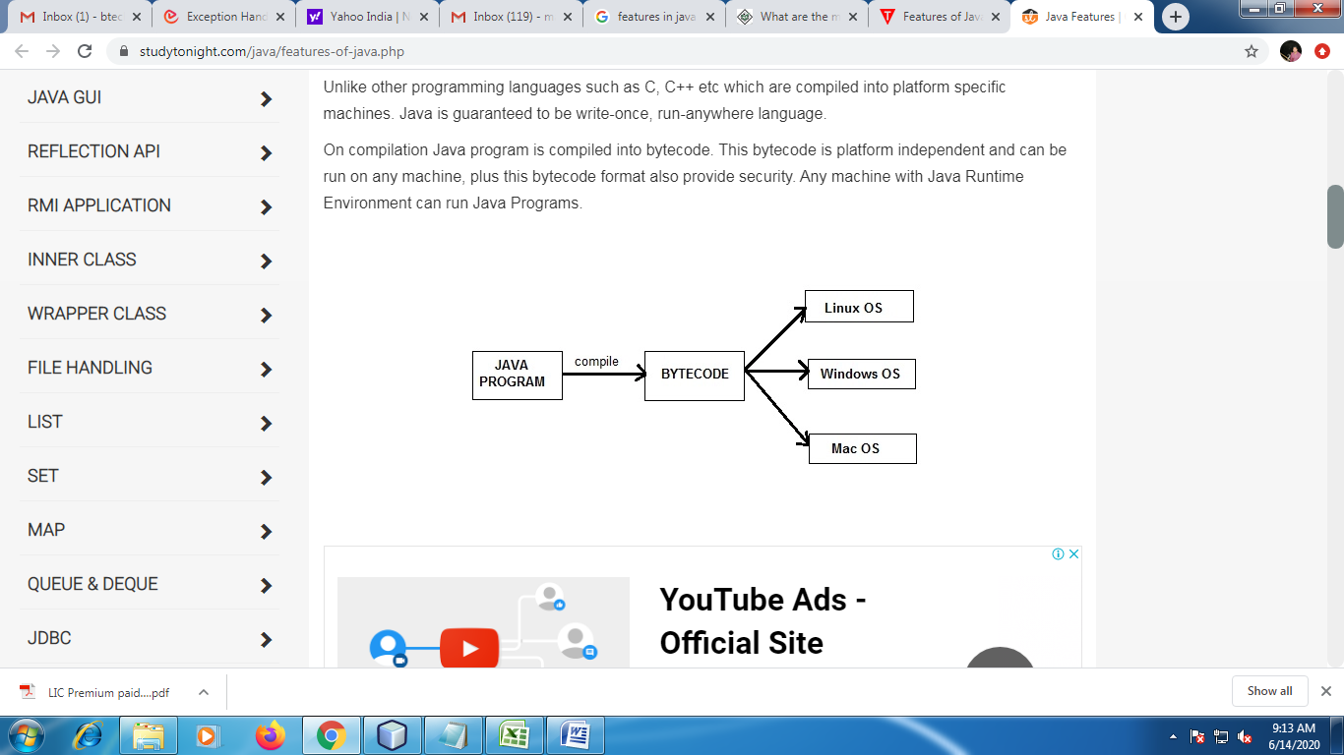

1. **Architecture Neutral**

Because of Byte code you can run Java code on any hardware configuration.

1. **Portable**

We may carry the Java byte code to any platform.

1. **High Performance**

Java is an interpreted language, so it will never be as fast as a compiled language like C or C++. But, Java enables high performance with the use of just-in-time compiler.

“Java has so many feature which is help to high performace. like oop, multhreading, Exception handling etc.”

1. **Multithreading**

Thread means it’s a part of process which handles one particular job at a time. If more than one thread in the program i.e known as multithreaded application. Multitasking is possible because of multithreading. Threads are important for many application such as gaming, multi-media, web applications etc.

1. **Dynamic**

In Java, memory allocation is takes place always dynamically.

**CLASSPATH**

1. CLASSPATH describes a location where all required files are available which is used in our application.
2. Java compiler and JVM will use CLASSPATH to locate required files.
3. If we do not set CLASSPATH then Java compiler will not able to find required files hence you will get error.

**PATH**

1. PATH variable is set to provide path for all java tools like javac, java, appletviewer.
2. PATH describes a location where binary executables are available.
3. If we do not set PATH then our system will not be able to find where javac is; hence it will not work. It is mandatory to set path.

**How to set path in Java**

If you are saving the java source file inside the jdk/bin directory, path is not required to be set because all the tools will be available in the current directory.

But If you are having your java file outside the jdk/bin folder, it is necessary to set path of JDK.

**There are 2 ways to set java path:**

1. Temporary
2. Permanent

### 1) How to set Temporary Path of JDK in Windows

To set the temporary path of JDK, you need to follow following steps:

* Open command prompt
* copy the path of jdk/bin directory
* write in command prompt: set path=copied_path

For Example:

**set path=C:\Program Files\Java\jdk1.7.0_15\bin**

2) How to set Permanent Path of JDK in Windows 7

For setting the permanent path of JDK, you need to follow these steps:

Go to MyComputer properties ->Click on Advanced system settings -> select Advance Tab ->click on environment variables -> click on new button of user variable

write

**Variable name: path**

**Variable Value:** path of bin folder ( eg: c:\Program Files\Java\jdk1.8_51\bin;.;)

-> write path of bin folder in variable value -> ok -> ok -> ok

